RESTAURANT AND CAFE WEBSITE
HTML and CSS Project

Project Description
Food Paradise is a sample restaurant and cafe website. It displays food menu items and prices, chef profiles, restaurant ambience, customer testimonials, opening hours, location details, and a table reservation form. The layout uses responsive cards and elegant typography.

Website Output Page
The following is an illustrative preview of the website layout. The live website loads the food and restaurant photographs from the image links in the HTML code when internet access is available.
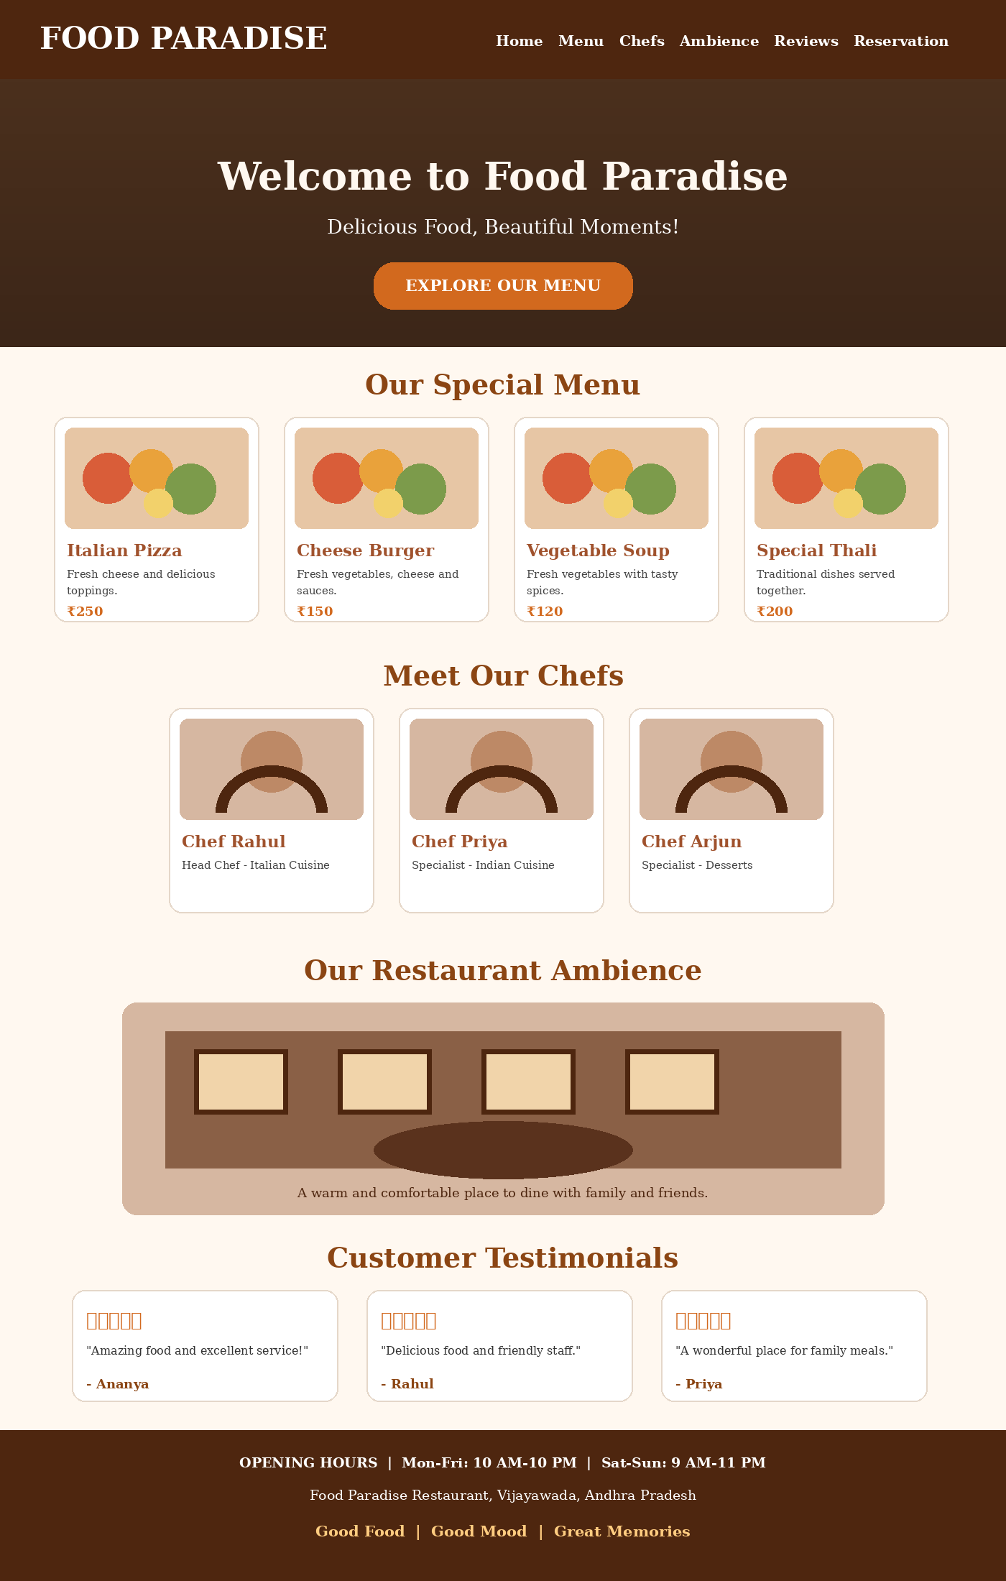

HTML Code (index.html)
<!DOCTYPE html>
<html lang="en">
<head>
<meta charset="UTF-8">
<meta name="viewport" content="width=device-width, initial-scale=1.0">
<title>Food Paradise Restaurant</title>
<link rel="stylesheet" href="style.css">
</head>
<body>
<header>
<h1>🍽 Food Paradise</h1>
<nav>
<a href="#home">Home</a>
<a href="#menu">Menu</a>
<a href="#chefs">Chefs</a>
<a href="#about">Ambience</a>
<a href="#reviews">Reviews</a>
<a href="#reservation">Reservation</a>
</nav>
</header>

<section class="hero" id="home">
<h2>Welcome to Food Paradise</h2>
<p>Delicious Food, Beautiful Moments!</p>
<a href="#menu" class="btn">Explore Our Menu</a>
</section>

<section id="menu">
<h2>Our Special Menu</h2>
<div class="container">
<div class="card">
<img src="https://images.unsplash.com/photo-1565299624946-b28f40a0ae38?w=500" alt="Pizza">
<h3>Italian Pizza</h3>
<p>Fresh cheese, vegetables and delicious toppings.</p>
<h4>₹250</h4>
</div>
<div class="card">
<img src="https://images.unsplash.com/photo-1568901346375-23c9450c58cd?w=500" alt="Burger">
<h3>Cheese Burger</h3>
<p>Fresh vegetables with tasty cheese and sauces.</p>
<h4>₹150</h4>
</div>
<div class="card">
<img src="https://images.unsplash.com/photo-1547592180-85f173990554?w=500" alt="Soup">
<h3>Vegetable Soup</h3>
<p>Fresh vegetables with delicious spices.</p>
<h4>₹120</h4>
</div>
<div class="card">
<img src="https://images.unsplash.com/photo-1517248135467-4c7edcad34c4?w=500" alt="Restaurant food">
<h3>Special Thali</h3>
<p>A delicious combination of traditional dishes.</p>
<h4>₹200</h4>
</div>
</div>
</section>

<section id="chefs">
<h2>Meet Our Chefs</h2>
<div class="container">
<div class="card">
<img src="https://images.unsplash.com/photo-1577219491135-ce391730fb2c?w=500" alt="Head chef">
<h3>Chef Rahul</h3>
<p>Head Chef - Italian Cuisine</p>
</div>
<div class="card">
<img src="https://images.unsplash.com/photo-1583394293214-28ded15ee548?w=500" alt="Chef">
<h3>Chef Priya</h3>
<p>Specialist - Indian Cuisine</p>
</div>
<div class="card">
<img src="https://images.unsplash.com/photo-1574966739987-65e38e9f7d5c?w=500" alt="Chef">
<h3>Chef Arjun</h3>
<p>Specialist - Desserts</p>
</div>
</div>
</section>

<section id="about">
<h2>Our Restaurant Ambience</h2>
<div class="ambience">
<img src="https://images.unsplash.com/photo-1517248135467-4c7edcad34c4?w=700" alt="Restaurant interior">
<p>Food Paradise offers a beautiful and comfortable dining environment.
Enjoy delicious food with family and friends in a peaceful atmosphere.</p>
</div>
</section>

<section id="reviews">
<h2>Customer Testimonials</h2>
<div class="container">
<div class="card">
<h3>⭐⭐⭐⭐⭐</h3>
<p>"Amazing food and excellent service. I loved the atmosphere!"</p>
<h4>- Ananya</h4>
</div>
<div class="card">
<h3>⭐⭐⭐⭐⭐</h3>
<p>"The food was delicious and the staff were very friendly."</p>
<h4>- Rahul</h4>
</div>
<div class="card">
<h3>⭐⭐⭐⭐⭐</h3>
<p>"A wonderful place to enjoy meals with family."</p>
<h4>- Priya</h4>
</div>
</div>
</section>

<section id="location">
<h2>Opening Hours & Location</h2>
<div class="info">
<h3>🕒 Opening Hours</h3>
<p>Monday - Friday: 10:00 AM - 10:00 PM</p>
<p>Saturday - Sunday: 9:00 AM - 11:00 PM</p>
<h3>📍 Restaurant Location</h3>
<p>Food Paradise Restaurant, Vijayawada, Andhra Pradesh.</p>
<p>Contact: +91 98765 43210</p>
</div>
</section>

<section id="reservation">
<h2>Book Your Table</h2>
<form>
<label>Full Name</label>
<input type="text" placeholder="Enter your name" required>
<label>Email Address</label>
<input type="email" placeholder="Enter your email" required>
<label>Phone Number</label>
<input type="tel" placeholder="Enter phone number" required>
<label>Reservation Date</label>
<input type="date" required>
<label>Reservation Time</label>
<input type="time" required>
<label>Number of Guests</label>
<select required>
<option value="">Select Guests</option>
<option>1 Person</option>
<option>2 People</option>
<option>3 People</option>
<option>4 People</option>
<option>5 or More</option>
</select>
<button type="submit">Reserve Now</button>
</form>
</section>

<footer>
<h3>Food Paradise Restaurant</h3>
<p>Good Food | Good Mood | Great Memories</p>
<p>© 2026 Food Paradise. All Rights Reserved.</p>
</footer>
</body>
</html>

CSS Code (style.css)
* {
margin: 0;
padding: 0;
box-sizing: border-box;
font-family: Georgia, serif;
scroll-behavior: smooth;
}

body {
background-color: #fff8f0;
color: #333;
}

header {
background-color: #4e260f;
color: white;
padding: 20px;
display: flex;
justify-content: space-between;
align-items: center;
flex-wrap: wrap;
}

header h1 { font-size: 28px; }

nav a {
color: white;
text-decoration: none;
margin: 10px;
font-size: 16px;
}

nav a:hover { color: #ffcc80; }

.hero {
background: linear-gradient(#0007, #0007),
url("https://images.unsplash.com/photo-1517248135467-4c7edcad34c4?w=1200");
background-size: cover;
background-position: center;
text-align: center;
color: white;
padding: 130px 20px;
}

.hero h2 { font-size: 45px; margin-bottom: 20px; }
.hero p { font-size: 22px; margin-bottom: 30px; }

.btn {
background-color: #d2691e;
color: white;
padding: 13px 25px;
text-decoration: none;
border-radius: 25px;
}

.btn:hover { background-color: #8b4513; }

section { padding: 50px 20px; }

section h2 {
text-align: center;
color: #8b4513;
font-size: 32px;
margin-bottom: 35px;
}

.container {
display: flex;
justify-content: center;
flex-wrap: wrap;
gap: 25px;
}

.card {
background-color: white;
width: 280px;
padding: 18px;
border-radius: 12px;
text-align: center;
box-shadow: 0 4px 10px #0002;
transition: 0.3s;
}

.card:hover {
transform: translateY(-8px);
box-shadow: 0 8px 15px #0003;
}

.card img {
width: 100%;
height: 190px;
object-fit: cover;
border-radius: 10px;
}

.card h3 { color: #a0522d; margin: 15px 0; }
.card p { line-height: 1.5; margin-bottom: 10px; }
.card h4 { color: #d2691e; margin-top: 10px; }

.ambience {
max-width: 850px;
margin: auto;
text-align: center;
}

.ambience img {
width: 100%;
border-radius: 15px;
max-height: 400px;
object-fit: cover;
}

.ambience p {
margin-top: 20px;
font-size: 18px;
line-height: 1.7;
}

.info {
background-color: #fff;
max-width: 700px;
margin: auto;
padding: 30px;
border-radius: 12px;
text-align: center;
box-shadow: 0 4px 10px #0002;
}

.info h3 { color: #8b4513; margin: 20px 0 12px; }
.info p { margin: 10px; }

form {
background-color: white;
max-width: 500px;
margin: auto;
padding: 30px;
border-radius: 12px;
box-shadow: 0 4px 10px #0002;
}

form label {
display: block;
margin-top: 15px;
font-weight: bold;
}

form input, form select {
width: 100%;
padding: 12px;
margin-top: 8px;
border: 1px solid #ccc;
border-radius: 6px;
}

form button {
width: 100%;
background-color: #8b4513;
color: white;
border: none;
padding: 14px;
margin-top: 20px;
border-radius: 6px;
cursor: pointer;
font-size: 17px;
}

form button:hover { background-color: #d2691e; }

footer {
background-color: #4e260f;
color: white;
text-align: center;
padding: 25px;
}

footer p { margin-top: 10px; }

@media (max-width: 768px) {
header {
flex-direction: column;
gap: 15px;
}
nav { text-align: center; }
nav a {
display: inline-block;
margin: 8px;
}
.hero h2 { font-size: 30px; }
.card {
width: 100%;
max-width: 400px;
}
}

How to Run the Website
- Create a folder named Restaurant-Website.
- Save the HTML code in a file named index.html.
- Save the CSS code in a file named style.css in the same folder.
- Open index.html in Google Chrome or another web browser.
- Keep an internet connection active to load the online photographs.
Note: The reservation form is a front-end demonstration. A backend or reservation service is required to receive and store actual table bookings.

